Changes due to GhIPSS Engagement Today – 7th August 2025
============================= Issue 1 ===========================
This is the flow for Billers Notification from GhIPSS: Notification from GhIPSS to Biller
Refer to Module B_v1.6 Pages 5- 7
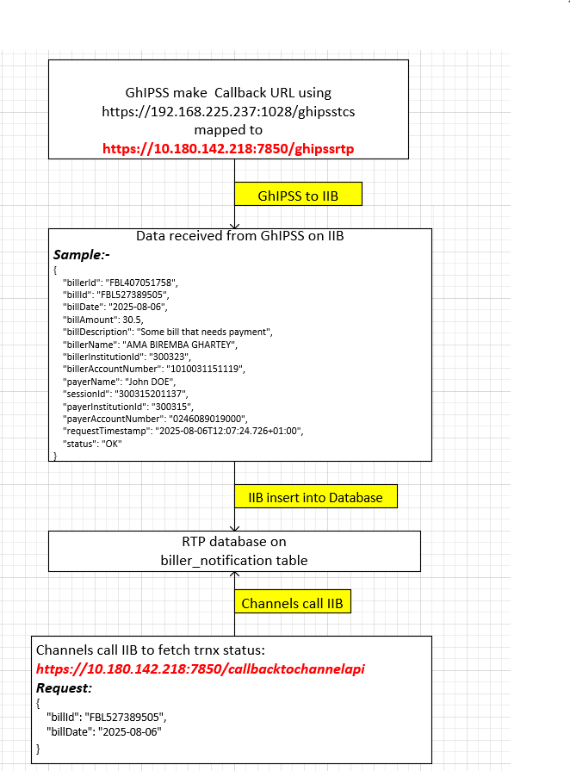

Flow Diagram Explanation:
- GhIPSS make Callback URL using https://192.168.225.237:1028/ghipsstcs which is mapped to IIB URL: https://10.180.142.218:7850/ghipssrtp
{
"institutionId" : "300323",
"billerId" : "FBL407051758"
}
- GhIPSS send to bank – Notification from GhIPSS to Biller response:
Sample:
{
"billerId": "FBL407051758",
"billId": "FBL527389505",
"billDate": "2025-08-06",
"billAmount": 30.5,
"billDescription": "Some bill that needs payment",
"billerName": "AMA BIREMBA GHARTEY",
"billerInstitutionId": "300323",
"billerAccountNumber": "1010031151119",
"payerName": "John DOE",
"sessionId": "300315201137",
"payerInstitutionId": "300315",
"payerAccountNumber": "0246089019000",
"requestTimestamp": "2025-08-06T12:07:24.726+01:00",
"status": "OK"
}
- IIB insert received Notification from GhIPSS to Biller payload into biller_notification table on RTP database
- IIB response to GhIPSS with:
{
"errorCode":"200",
"errorDescription":"success"
}

------------------------- Channels call IIB to check Transaction status -------------------------------

- Channel call IIB URL: https://10.180.142.218:7850/callbacktochannelapi/
==> deploy this service on 2 EGs (7850 and 7860)
Channel send request:
sample:
{
"billId": "GH7389505", -- XXXXXXX
"billDate": "2025-08-06" -- YYYYYYY
}

- IIB uses this script to fetch transaction status:
Select billerId, billId, billDate, billAmount, billDescription, payerName, payerAccountNumber, status from biller_notification where billId = XXXXXXX and billDate = YYYYYYY
- IIB response to Channel:
Response sample:
{
"billerId":"6Y262Y26111",
"billId":"GH782882",
"billDate":"2019-05-31",
"billAmount":123.45,
"billDescription":"Some bill that needs payment",
"payerName":"John DOE",
"payerAccountNumber": "0123456789012",
"status":"Success"
}

===================== Issue 2 ================
For BillerPayment Individual and BillerPayment Bulk in the request payload validate the value in the billAmount field:
Thus:
sample
{
"billId": "GH782882",
"transactionStatus": "The billAmount value of a Transfer Request must be > 0"
}

===================== Issue 3 ================
For billerpaymentstatus - https://10.180.142.218:7850/billerpaymentstatus

If BillerPayment_Individual is successful and billerpaymentstatus call is invoked, it gives wrong billAmount:-

Thus:
BillerPayment_Individual Request --- https://10.180.142.218:7850/billerpayment_indiv
Request
{
"operation": "billerpayment",
"billerId": "FBL407051758",
"billId": "FB1234200",
"billDate": "2025-08-01",
"billAmount": "80.80",
"payerInstitutionId": "300315",
"payerAccountNumber": "0246089019000",
"payerName": "John DOE",
"billDescription": "Some bill that needs payment",
"requestTimestamp": "2025-08-01T14:38:24.726+01:00"
}

Response:
{
"errorCode": 200,
"errorDescription": "Transaction processing in progress"
}

billerpaymentstatus Request --- https://10.180.142.218:7850/billerpaymentstatus
request:
{
"operation": "transactionStatus",
"billerId": "FBL407051758",
"billId": "FB1234200",
"billDate": "2025-08-06"
}

Response:

{
"billAmount": "50.45",
"billDate": "2025-08-01",
"billDescription": "Some bill that needs payment",
"billId": "FB1234590",
"billerId": "FBL407051758",
"payerAccountNumber": "0246089019000",
"payerName": "John DOE",
"status": "Success"
}

Amount in billerpayment_individual: "billAmount": "80.80"
Amount in billerpaymentstatus: "billAmount": "50.45"

The expected Amount in billerpaymentstatus should be “billAmount": "80.80"

